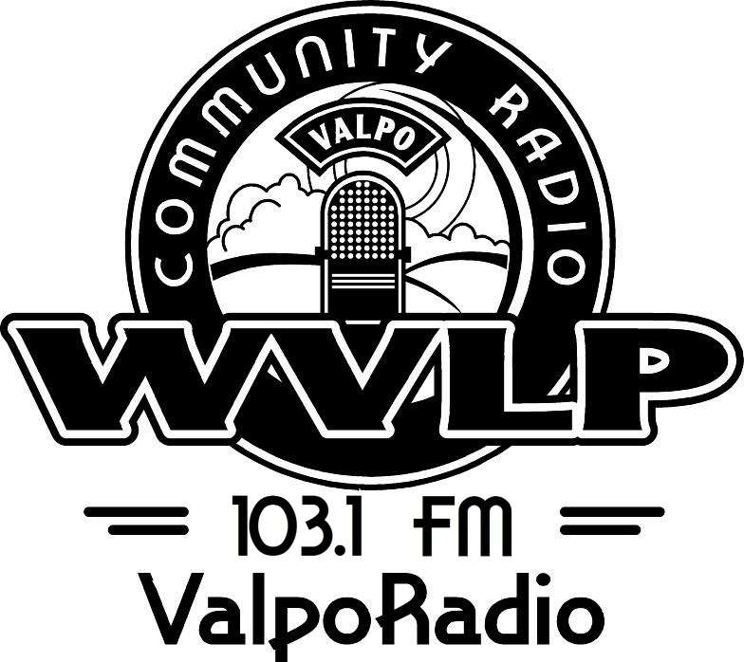

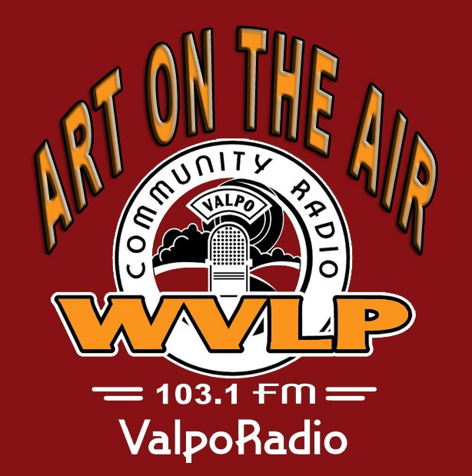
UNDERWRITER PROPOSAL for ART ON THE AIR
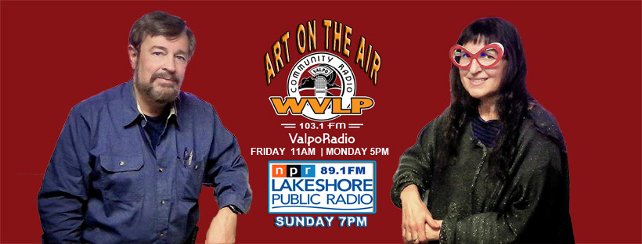 | ART ON THE AIR  WVLP 103.1 FM  The Technical Building  1150 Lincolnway  Valparaiso, IN 46385

SHOW: ART ON THE AIR
HOSTS: Larry A Brechner and Ester Golden
FORMAT: One Hour Live Talk (10-15min local art events calendar / 45min guest interview)
STATION: WVLP 103.1 FM (Valparaiso) Streaming live 24/7 at WVLP.org
TIME SLOT: Live Friday 11am CT rebroadcast Monday 5pm CT / Sunday 7pm on Lakeshore Public Radio 89.1 FM
TOPIC: Art Events and Guests from Northwest Indiana (Lake, Porter, LaPorte counties)
WEB: Website brech.com/aota show archive and arts event calendar Facebook facebook.com/artontheairwvlp
PODCAST: Anchor.fm, NPR ONE, Spotify, Apple, Google, Breaker, Castbox, Overcast, Pocket Cast, Radio Public

SHOW SUMMARY
ART ON THE AIR (AOTA) is an hour-long show / podcast that opens with a short interview about local art events in Northwest Indiana's three county area, then continues to the long-form interview portion. Guests include individual artists, photographers, gallery owner/curators, festival sponsors, authors, the shakers and movers in NW Indiana’s art, theater, and music scene, plus much more. Hosts are Larry A Brechner, long-time theater director, photographic artist, and arts organization board member, and Ester Golden, owner of The Nest in Michigan City.

UNDERWRITER PROPOSAL
ART ON THE AIR (AOTA) is seeking to expand underwriters for our program. AOTA delivers a weekly target demographic audience of people both interested and participating in the vibrant arts, music, theater community throughout Northwest Indiana. AOTA through WVLP directly reaches Valparaiso and the larger Porter County community, but AOTA added more coverage in 2019 by also being rebroadcast on Lakeshore Public Radio 89.1FM that has a much larger coverage area centered in Lake County but also reaching Porter, LaPorte counties plus into adjacent Illinois. AOTA is available streaming live during both broadcasts world-wide plus all shows may be either downloaded or heard as podcasts making underwriting more valuable. Underwriters appear on the AOTA website with hyperlinks back to their webpage. AOTA’s Facebook page connects with numerous regional art pages and at present receives an average of over 1000 organic views per week.
If your business or organization is interested in underwriting ART ON THE AIR, please feel free to contact me to discuss your interest Larry A Brechner at LAB@brech.com or 219 746-6609 AOTA website and Show Archive at brech.com/aota. Attached is the complete underwriter proposal.
www.wvlp.org Email: info@wvlp.org Phone: 219-476-9000 1150 Lincolnway, Suite G2 / Valparaiso, IN 46385
WHY UNDERWRITE?
BUILD A BETTER IMAGE FOR YOUR BUSINESS
As Valparaiso experiences growth, underwriting will enable you to keep your business in the public eye. It will also provide
you with the opportunity to reach thousands of people at a time. With underwriting, your business becomes a vital presence
in the community. The image you create through sponsorship will increase your visibility and create a positive image among
your peers and your customers.
IT’S COST-EFFECTIVE AND TAX-DEDUCTABLE
Not only will your business be featured in on air spots and on our stream, your business info will also be displayed on our
web site and face book pages. WVLP is a 501[c]3 nonprofit organization making all your underwriting dollars tax-
deductable.
WHY RADIO?
REACH PEOPLE, IN THE CAR, AT THE OFFICE AND ONLINE
Studies have shown that Americans spend an average of three hours a day tuned in to the only medium that has become their
constant travel and leisure companion – radio. Radio works Monday through Sunday and WVLP streams live worldwide!
Radio sponsorship creates a more intimate relationship between your business and the listening audience. With radio you can
create interest and command attention.
WHY WVLP?
WVLP!
WVLP is all about you. It’s about your family, friends and neighbors. It’s about the community we call home. Our mission is
to provide a voice for those in our community who traditionally have not had this advantage by presenting information and
entertainment programming with a strong local emphasis.
WE HAVE A PROVEN RECORD OF SUCCESS!
For more than ten years, WVLP has been an open forum for the voice of the people of Valparaiso and the surrounding areas.
WVLP offers unique local broadcasting: music, theater, community news, school reports, and interviews. You have an
opportunity to share in the presentation of this programming. WVLP is not for profit radio, which must be funded by
individuals, underwriters, and grants.
WE HAVE LISTENER LOYALTY
Listeners are loyal to us. We have clearly established ourselves as the driving force in local news, information and interesting
programming in Valparaiso.
WVLP RADIO IS PERSONAL
WVLP reaches all residents of Valparaiso and has a strong community focus, addressing local, national and global issues by
local voices. WVLP presents the passions and desires of its listeners in the community and we keep our doors open to those
in the community that have a passion to share.
WHAT WOULD WVLP MEAN TO YOU?
WVLP offers local businesses the opportunity to support community radio by underwriting and acknowledges support in a
way that can call significant attention to you and your business. WVLP underwriting is substantially less than commercial
radio or print media in the region, is tax-deductible, and brings something very positive to Valparaiso. WVLP spots are an
efficient and effective use of your business’s local “community “ dollars. Mentions effectively communicate your support of
non-profit, community radio without a “call to action”.
WVLP PROGRAMMING
NEWS PROGRAMMING
The Morning Show: The daily news brought to you by Gail Lutze and Jane Schreiner (Monday); Jane Schreiner and Jane
Sanders (Tuesday); David Keammerer and Fred Boehm (Wednesday); Larry Baas and Chris Pupillo (Thursday); and David
Keammerer and Biff Geiss (Friday).
DISCUSSION PROGRAMMING
Conversations With Community Voices: Talk-oriented programming with four revolving hosts, each with a different
mission. The rotating hosts are Paul Schreiner who delves into many areas, with topics which can be both serious and more
light-hearted; Dr. Larry Baas, who dedicates himself to salient issues, both national and local, and does so in an academic
manner; Don Evans and Buzz Bowen, who focus on local personalities and issues, and bring an earthy tone to the
conversation; and Valerie Steil and Dot Kesling, whose concentration is on the homemaker among us, the aim being good
taste and style.
The Buzz: Thematic discussions, national or local, between Paula and Robert Jackowski about controversial topics -- always
serious and sober in tone but never cynical or angry.
UTR: Sports talk with Bill Koch and Payton Ball. These guys know their sports – the Region’s equivalent of ‘Mike &
Mike”. A great place on the dial for the local sports enthusiast or the hardcore junkie. Combative but fun!
House Rap: Highly informative yet upbeat do-it-yourself show for home owners. Listen to lively bantor between two
gentlemen who bring a different area of expertise to each topic. The show consists of Paul Schreiner, general contractor, and
Mike Willard, tradesman and contractor.
What's Going On?: A show hosted by Jane Schreiner and Dot Pakan which is everything to do with what's going on in our
area with most of the attention being on Valparaiso.
Money Matters: Informative show about how to get more bang for your bug, with investment expert and wealth
management counselor, Greg Farrall, of Farrall Wealth, LLC. Greg’s tips will empower you in your financial life.
Community Matters: Informative show brought to you by American Legion which takes a look at what makes Valparaiso
the fine community it is. Emphasis on the positive with various guests each week telling us about what they do.
Art On The Air: Northwest Indiana has a rich and diverse art and performing arts community that is discussed weekly with
hosts Larry A Brechner and Ester Golden featuring artists, gallery owners, musicians, authors, theater, and so much more.
Valparaiso and the Region has a burgeoning visual arts community, and Larry A Brechner and Ester Golden have elevated the discussion by hosting various shakers and movers in their arts to discuss their area of interest.
The Information Playground: Want to protect yourself when you are online, connected to the world? Listen to expert Ron
Bush, who is armed with the best tips to keep your identity protected.
MUSIC PROGRAMMING
In addition to prominently featuring local artists, WVLP can also boast some great niche music programs which are hosted by
well-informed DJs and cover a wide range of music, from folk (Left Of Center or Songs from Camp) to jazz (Inner Mounting
Flame, Jazz, and The Jazz Scene); or the blues (Valpo Blues or The Blues Drive) to music for just about everybody else
(Progressive Rock to Punk, Traditional Country to Heavy Metal,or classical to live studio visits from some of Valpo's finest
artists).
SYNDICATED PROGRAMMING
Although WVLP prides itself on its own unique programming vision and creative broadcasters, it has carried pioneering
programs such as ‘Democracy Now!’, ‘Art Of The Song’, ‘Sounds From The Global Village’, and ‘The Jazz Scene’.
WVLP RATES
Basic Underwriter level
$300/year
Basic Underwriters receive 2 acknowledgements during one hour of the program. Plus 15-20 acknowledgements each week
Intermediate Underwriter level #2
$600/year
Intermediate level #2 Underwriters receive 2 acknowledgements during one hour of the program plus 22-26
acknowledgements each week.
Intermediate Underwriter level #1
$900/year
Intermediate level #1 Underwriters receive 2 acknowledgements during one hour of the program plus 30-35
acknowledgements each week.
Major Underwriter level
$1,200/year
Major Underwriters receive 2 acknowledgements during one hour of the program plus 40-45 acknowledgements each week
Major Underwriter level
$2,400/year
Major Underwriters receive 2 acknowledgements during one hour of the program plus 90-100 acknowledgements each week
In consideration for this contribution, Neighbors Broadcasting agrees to identify the underwriter as an underwriter on-air according to the rate card as
agreed above, in addition to being listed on the WVLP web site, newsletter, and other promotional material.
Payment remitted to: Neighbors Broadcasting 1150 Lincolnway, Suite G2 Valparaiso, IN 46385
Make checks payable to Neighbors Broadcasting
WVLP reserves the right to cancel this agreement in the event payment is not made within 30 days of the expiration of the contract term selected.
Announcement Wording: WVLP – 103.1 LPFM and underwriter will jointly develop a 20 second, objective, factual on-air announcement that may include Underwriter’s name; a slogan that identifies the Underwriter; Underwriter’s location; and a value neutral description of the product line or service of the Underwriter. WVLP – 103.1 LPFM will review and edit, as necessary, all acknowledgements to ensure compliance with the Federal Communication Commission regulations.
This agreement contains the full terms between Neighbors Broadcasting (owned by Neighbors Corp., tax ID # 35-1768550) and:
__________________________________________________________________
(Underwriter signature)
Name of underwriting entity ___________________________________________
Billing/Business address ______________________________________________
__________________________________________________________________
(for Neighbors Broadcasting)
___________________
(Date)
All expenses are a 501(c)3 charitable contributions unlike any radio stations
WVLP streams live!!
Website: www.wvlp.org Email: info@wvlp.org Phone: 219-476-9000
1150 Lincolnway, Suite G2 / Valparaiso, IN 46385
OUR REGIONAL COVERAGE
WVLP Broadcast Coverage  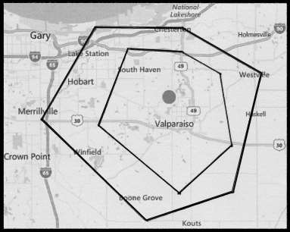 | Lakeshore Public Radio  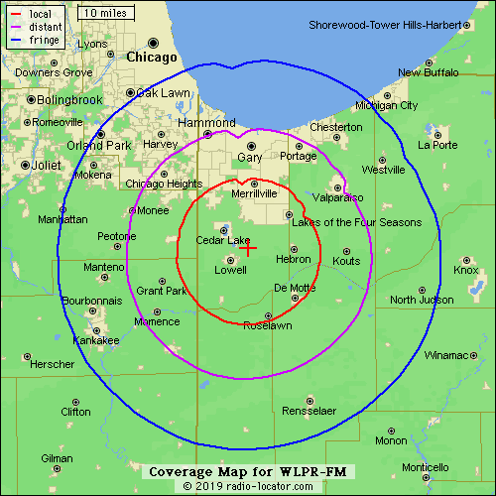
STREAMING WORLDWIDE

Website: www.wvlp.org Email: info@wvlp.org Phone: 219-476-9000
1150 Lincolnway, Suite G2 / Valparaiso, IN 46385
WVLP streams live!!

