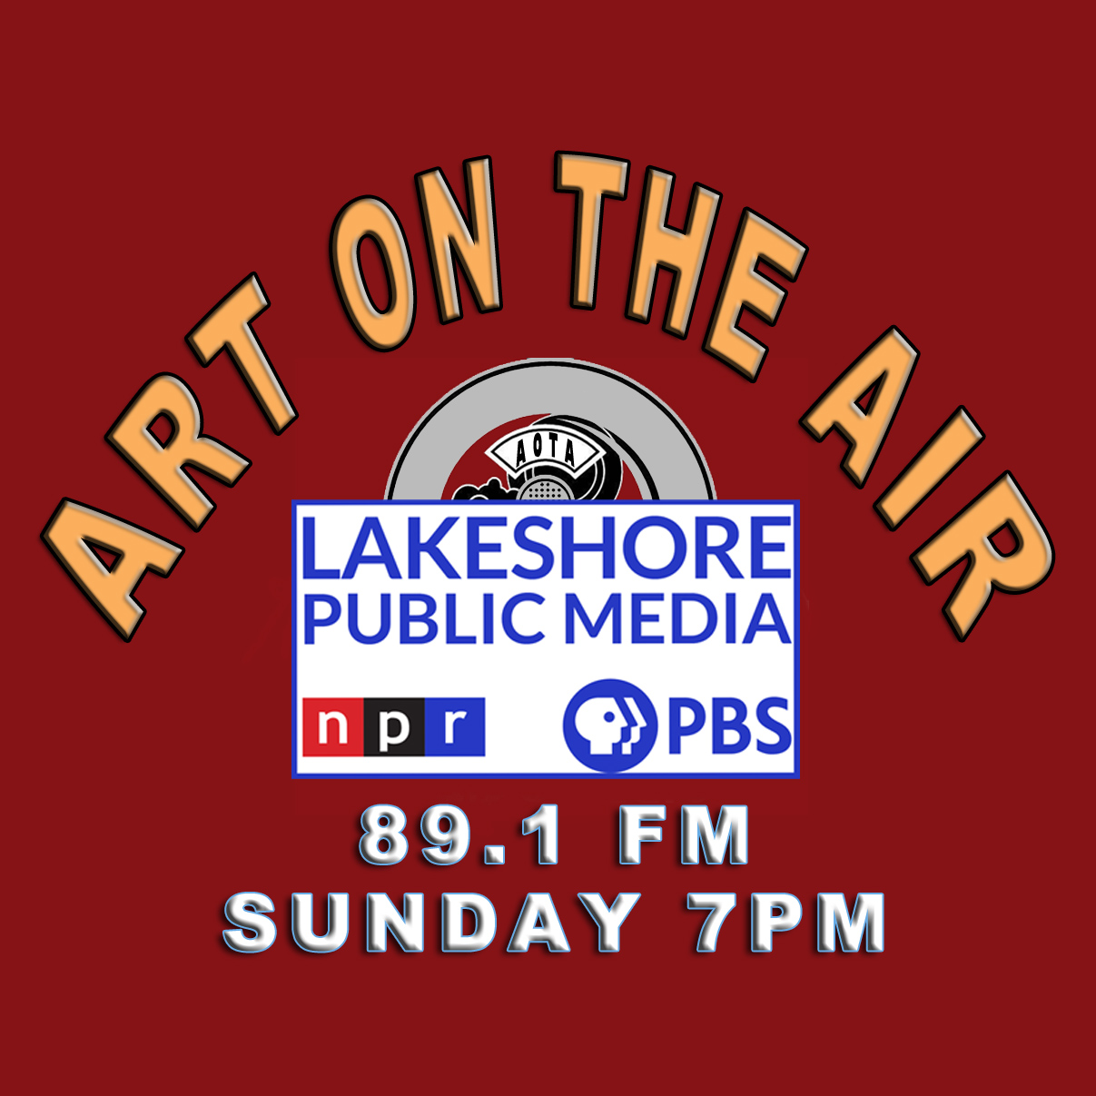 | ART ON THE AIR Underwriter PROPOSAL  for Lakeshore Public MEDIA 89.1FM | 
Show Summary
ART ON THE AIR is an hour-long radio show (available as a podcast) that opens with a short Spotlight Interview about local art events in Northwest Indiana's three county area, then continues with a long-form feature interview. Guests include individual artists, photographers, gallery owner/curators, festival sponsors, authors, musicians, the shakers and movers in NW Indiana, Chicago and beyond discussing the art, theater, the music scene, culture plus much more.
Hosts are Larry A Brechner, long-time musical theater director, photographic artist, and arts organization board member, and Ester Golden, artist and gallery/venue owner of The Nest in Michigan City. ART ON THE AIR is pre-recorded and produced from Larry's Chesterton-based home studio with co-host, Ester, and our guests connected remotely by using ZOOM. Both hosts receive no compensation for doing the show.

Overview
Art on the Air is heard weekly every Sunday at 7pm on Lakeshore Public Media 89.1FM.*
Art on the Air is available as a podcast on Lakeshore’s Website including NPR ONE.
Art on the Air is also available on most podcast platforms including:
Spotify, Tune In, Apple/TuneIn, iHeart, Amazon Music, Goggle, Pandora, smart speakers (Alexa, etc.).
Every show is available is perpetuity on the Art on the Air website (brech.com/aota).
*A seven-minute Spotlight segment that is part Sunday’s show is also heard twice on Wednesdays.
Benefits and Exposure
Association as a supporter of the arts/culture/music for Northwest Indiana.
Association with your local Pubic Radio station and the NPR brand.
NPR listeners opinion of a business is more positive when they find out it supports public radio.
A target audience of listeners interested arts, music, and culture.
Hosts Larry A Brechner and Ester Golden are deeply involved in the regional art scene.
Internal mention during program as a supporter
“Art on the Air is brought to every week on Lakeshore Public Media by (Underwriter name).”
Internal mention after the Spotlight segments on Wednesdays (two times).
Listing on the Art on the Air website with links to the underwriter.

Reach Lakeshore Public Media | 8625 Indiana Place Merrillville, IN 46410 | 219-756-5656
Lakeshore Public Media over-the-air reaches the seven county area of Northwest Indiana.
Extended fringe coverage in Southeast Michigan, Chicago, and surrounding counties.
Lakeshore Public Media streams live from its website and on Tune IN reaching a wider audience.
*(Art on the Air is also heard on WVLP 103.1 FM, Fridays at 11am and Mondays 5pm)

Underwriting Rates Underwriting support is tax deductable to Lakeshore Public Radio (501[c]3 nonprofit organization)
Exclusive Underwriter 52-weeks for $50 per week ($2600 annually) exclusive
Partial Underwriter 52-weeks for $25 per week ($1300 annually) shared x2
Quarter Underwriter 52-weeks for $12.50 per week ($ 650 annually) shared x4

Any questions or interest in becoming an Art on the Air underwriter please call:
Larry A Brechner 219 746-6609 AOTA@brech.com
Ester Golden 219 210-2263 thenestmichigancity@gmail.com
Website: brech.com/aota/ Lakeshore: lakeshorepublicmedia.org/show/art-on-the-air

